Application for Funding Under FOA: DOE-EE0007080
FORGE Solicitation 2020-1
Area of Interest 1:
Devices Suitable for Sectional (zonal) Isolation Along Both Cased and Open-hole Wellbores under Geothermal Conditions

Development of a Smart Completion & Stimulation Solution

May 26, 2020

Principal Investigators
Welltec® - Ricardo Vasques
Welltec® - Yosafat Esquitin
Welltec® - Soren Hallundbaek
Welltec® - Ryan Melander
O.U. - Ahmad Ghassemi
O.U. - Catalin Teodoriu

DUNS Number 092-900-351

Administrative Point of Contact of Applicant:
Ryan Melander, Business Development Manager
Welltec®, Inc.
22440 Merchants Way, Katy TX, 77449
Contact:
Email: rmelander@Welltec®.com
Cell: 817-805-5987

  - Project Overview:
Background:
General introduction/problem area combing WT and OU’s proposed contribution

Welltec Background: Welltec's was founded based on its founder's university thesis leading to the invention of the Well Tractor and the establishing of Welltec® in 1994, which has since grown to a multinational organization employing over 850 people world wide. The original Well Tractor transformed the industry by facilitating the deployment of intervention tools into horizontal and highly deviated wells, without involving heavy or large amounts of equipment.

Welltec’s commitment to innovation runs deep in its DNA, as does the ongoing aim to improve existing practices. Welltec’s lightweight Intervention solutions are based on advanced engineering, clean technology, and a determination to enhance safety, enabling us to reduce environmental risks, fuel consumption, and carbon footprints throughout the extraction process.
In 2010 Welltec® expanded into the Completion side of the industry and designed an expandable metal packer – the Welltec® Annular Barrier (WAB®). The main advantages of the WAB® are a reduction in the use of cement for well construction, and minimization of Sustained Casing Pressure (SCP). By addressing these challenges, improved well integrity is delivered that lowers the risk of blow-outs and removes the need for flaring of harmful gases, thereby providing
environmental benefits through innovative solutions, promoting safer and more sustainable types of energy for generations to come.
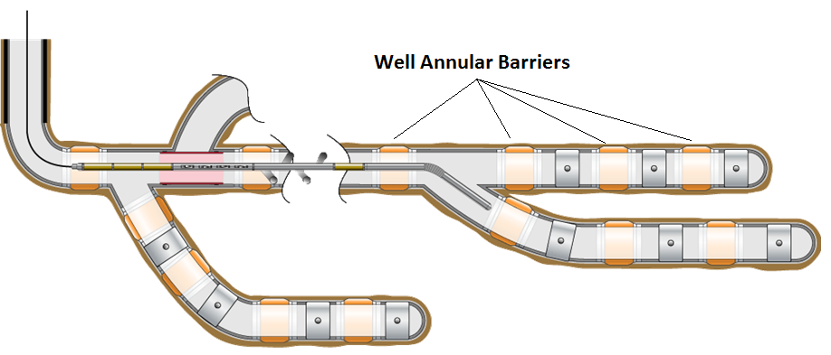
Figure 1 - Multilateral well concept – WAB® and Welltec® tractor illustrations
Since the market introduction, Welltec® has developed a significant operational track record with successful qualification and a worldwide deployment track record of over 500 to date.
Welltec’s geothermal track record in the Asia Pacific, has thus far combined the metal expandable packers (WAB®) with cementing to help geothermal operators achieve isolation in highly challenging, high temperature conditions. Allowing geothermal operators to benefit from Welltec’s more than 25 years of expertise providing innovative solutions. Currently, Welltec® is actively participating in some of the most important geothermal projects around the globe, frombeing a part of Geothermica’s ZoDrEx Consortium to US DOE projects. Most recently, for Zonal Isolation in man-made geothermal wells.

Project Goal: The main goal of this project is to develop an isolation system capable to witstand geothermal downhole conditions and mitigate the propeblems experienced by conventional packers in FORGE wells. While the WAB® has proven its ability to meet up to 10,000 psi differential pressures and create a gas-tight seal against an impermeable barrier, its operation is limited in temperature by the use of elastomeric seals. The successful completion of this project would eliminate the use of elastomers on the WAB® construction, raising its operation to envelop to over 250 DegC with minimal material degradation expected during the life of the well. Along with enhancements to the WAB’s design to facilitate and support better conditions for stimulation management.
To achieve these technological improvement on the WAB® design, the following critical success factors are required:
- Expansion capability - The all-metal design must be able to withstand the plastic deformation required during the product actuation. The product is expected to achieve a minimum of 20% increase in diameter without failure (measured in the expansion sleeve ID). The expansion will be performed using 6,000 psi differential pressure.
- Sealing capability – The design must be able to achieve 6,000 psi with a leak criterion of less than 1 ltr/min at 225 DegC
- Temperature capability – The device should be able to be actuated and tested at 225 DegC. Further pressure testing at 250 DegC should have less than 10% degradation on its sealing capabilities.
The optimal goal will be to provide zonal isolation that enables Enhanced Geothermal Systems (EGS) with more manageable conditions during stimulation in extreme downhole environments, allowing for optimal output per well.

Reproducible EGS Technologies: Always focused on the future, we aim to embed automated processes throughout our manufacturing centers. Now contributing to the vast majority of equipment output, the advantages of CNC Robotics are clear, further reinforcing our stated aim to deliver safe, fast, reproducible, and faultless services.
The proposed zonal isolation WAB solution will be apllicable in both EGS and conventional geothermal systems. Furthermore the system is scalable to any well length and size. Allowing for a standaized tailoring that can be adapted to individual formation challenges, stimulated formations or a combination of artificial and natural fractures and fault, the zonal isolation will allow for well design that reduces risk and optmizes output.

DOE Impact: The funds provided by DOE will allow Welltec® to provide a suitable and tested solution to allow effective EGS systems to be developed, tested and safely deployed in a selected well. Our project team's focus is to build, test, and qualify the working capabilities of a complete zonal isolation system incorporating the WAB®to the current standard designs (Slotted Liner) or with an enhanced stimulation valves for more effective treatments.
Welltec® has the capability to design, model, and qualify the system required for geothermal applications. However, Welltec® lacks internal resources and thus requires DOE funding assistance. DOE funding will be used to procure the test equipment, materials, and prototypes required, as well as personnel.
Welltec® understands that 1400 new wells are required each year globally to meet current targets (Geothermal Resources Council; 2017). Wells above 225 DegC will be the target application area for the proposed non-elastomer WAB® and are expected to represent a significant percentage of the market.
The OU partner team will provide not only the necessary theoretical and laboratory investigations but through the training of involved students will provide the next generation of geothermal trained engineers.

  - Technical Description, Innovation, and Impact
Relevance and Outcomes: To enable FORGE and future EGS stimulation designs relying on multi-stage fracturing, new zonal isolation technologies are needed. The ability to isolate a previously stimulated zone improves the probability of reaching out further and increasing the formations potential. Traditional isolation methods involves either the use of a permanent packer solution, where the packer will have to be drilled out to be removed or a retrievable packer solution. With retrievable often being limited by the design, which ultimately limits the range and scale of the stimulation campaign. Therefore robust zonal isolation helps to ensure the geometry of the well and the direction of fracture propagation. The majority of the isolation systems rely on elastomeric or equivalent deformable sealing elements that are compressed by the mechanical system to reach the wellbore face to create the seal. Other isolation systems available are the chemical isolation systems such as cement, resins, or polymers that are pumped behind a casing or liner.
The most effective technology to achieve controllable isolation is the use of a mechanical component that creates precise contact between the tool and the wellbore to be isolated. The component used as sealing element must be temperature restant and this is the reason why we propose a metallic type sealing element. The objective of this project is to qualify a novel technology, which enables our users to optimize the management and development of EGS by combining several Welltec technologies, optimizing them for FORGE selected wells and qualifying them in the laboratory prior deplyment. By incorporating the WellTec WAB® (see section on previous work) with standard methods, such as slotted liners or pre-perforated pipe, in combination with a polished bore seal system, will allow for selective zonal stimulation with long term resistance and multiple re entries. Combining the WAB® with the WFVTM will not only allow having effective zonal isolation. Still, it will enable the enhanced injection/production through a downhole controlled inflow system, which will deliver the optimal stimulation and production in EGS. Our proposed system will give the flexibility to stimulate unlimited zones from the top-down, bottom-up, or selectively while maintaining zonal isolation for initial and future stimulations. The WAB/WFV combination will also help reduce and eliminate risk, by making it possible to shut off any zones that could compromise the overall integrity of the well, should such be encountered or occur in the form of lose zones or problems stemming from shadow stress clusters. To date no such attempt has been done to optimize isolation tools for geothermal application that includes rock mechanics expermental and numerical investigations and full scale testing and qualification..

Feasibility: Welltec's existing WAB® technology can demonstrate the technical feasibility of this project. The sleeve is manufactured with a high ductility alloy that hardens as it strains, the result is a uniform expansion of the material that conforms to the borehole shape.
Many design iterations and bench tests of the WAB® have been performed. Detailed Finite Elemental Analysis (FEA) models (Figure 6). The packer design is carefully selected to ensure it provided a sufficient contact pressure and seal capability in the worst-case borehole geometry (ISO 14310 standard).
This demonstrates Welltec's experience in this field and will ensure a clear understanding of what is required to achieve performance targets.
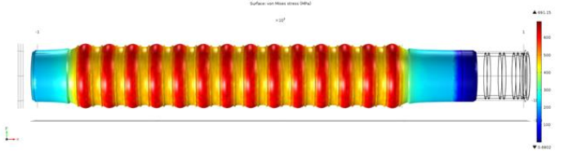

Figure 6 - FEA model displaying post-expansion strains
Welltec® has performed a vast number of qualification tests on the existing WAB® using in-house test facilities. The qualification of the existing barrier is conducted using the API 19 OH/ISO 14310 testing protocol. The WAB® is expanded into a test pipe that represents the most challenging performance conditions for the system. For pressure testing, the pressure is applied in three main areas, as defined in Figure 7. Pressure Pc is defined as the liner pressure or the pressure inside the barrier during the tests. Pressure Pa and Pressure Pb are defined as annular pressures.
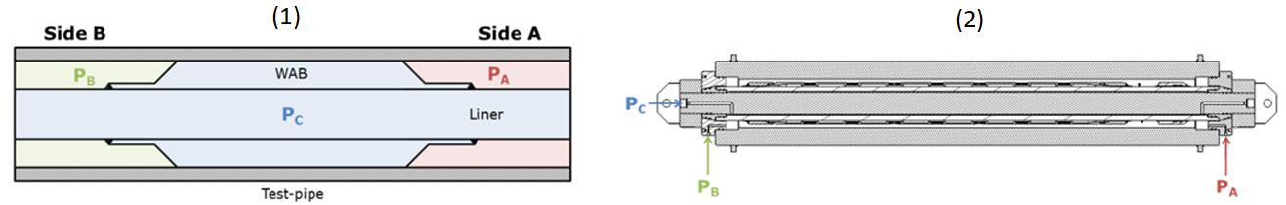

Figure 7 - (1) Simplified reference diagram for pressures throughout the system after expansion.
(2) Pressure connections identified on drawing of the test-jig.

Welltec® has also developed an advanced valve system, Welltec® Flow Valve (WFVTM), currently deployed in wells around the world in oil and gas applications. The proposed system designs will enhance the ability to selectively isolate and stimulate geothermal wells, through the replacement of an elastomer type packer with the Welltec® well known metallic technology.
The proposed full scale testing facility that will be build at OU as part of this project will be designed to go beyond the API testing protocol to include conditions specific to geothermal wells such as elevated temperature and long – term testing.

Summary of previous work

The WAB® uses a metal outer sleeve mounted on the OD of the liner or casing (Figure 2 - WAB® Mounted on the casing). The design is seamlessly integrated with the well completion as it utilizes the same casing or liner with no decrease in bore size. The ends of the metal outer sleeve are welded to the casing (liner). On the metal outer sleeve (expansion sleeve), surface pressure-activated elastomer seal elements are housed within seal carriers. The metal outer sleeve is hydraulically expanded, radially using well fluids to make contact with the formation. During the hydraulic expansion, the metal outer sleeve yields (the yield pressure is a function of the material grade, wall thickness, and the diameter) and then plastically deforms to conform to the open-hole profile. The metal outer sleeve is manufactured with a high ductility alloy that hardens as it expands.
The result is a uniform expansion of the material that conforms to the borehole shape, creating a long-lasting annular seal. Welltec® estimates that existing seals can last 20 years; the new seals proposed in this application will target a life of well performance. The current WAB® is resilient under varying well conditions and is unaffected by fluctuating environmental variables, i.e., salinity, viscosity, and temperature over the life of the well.
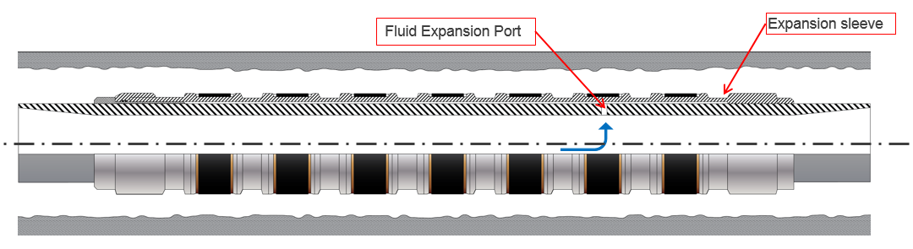

Figure 2 - WAB® Mounted on the casing
Figure 3 -Un-expanded WAB® Mounted on Casing Figure 4 - Expanded WAB® Mounted on Casing
The WAB® is currently under design for the DOE-FOA-0001945 (Zonal Isolation for Manmade Geothermal Wells) and will go under field deployment in 2021. Welltec® has also developed an advanced valve system currently deployed in wells around the world in oil and gas applications. The Welltec® Flow Valve (WFVTM) gives the user full reservoir management for stimulation/injection and allows the passage of proppants or other permeability modification materials, along with full borehole access. The all-metal WAB®, combined with the WFVTM, gives users the flexibility and forms a complete system for zonal isolation and zonal flow control for the life of the well. Allowing for maximum effective stimulation of multiple zones and reduces the uncertainty and risk associated with standard industry equipment and practices. An example is shown in Figure 1

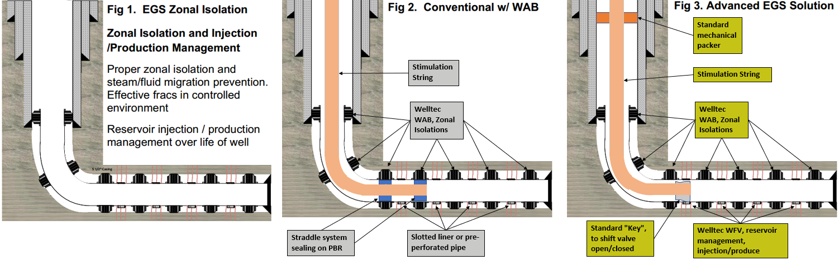
Figure 1.

In this document, we will refer to two different systems.
System (A) = WAB® + WFVTM (flex-well)
System (B) = WAB® + Slotted liner or pre-perforated pipe (standard or conventional methods)

Our concept uses the WAB®, expandable all-metal packer for zonal isolation as the base of the system, which has already been implemented in oil and gas applications to exceed the requirements of complete zonal isolation. The WAB® is currently under testing for geothermal applications. Both systems operate by hydraulically expanding the WAB's, sealing off each zone, and sealing off the lower completion to the intermediate casing, as seen in Figures 1 and 2. Hydraulically expanding the packers will be achieved depending on the method of communication to the reservoir. When the WAB® is deployed in system (A), the all-metal packers can hydraulically be expanded simultaneously, sealing off multiple zones. When the WAB® is deployed in system (B), a second trip will be required, and each WAB® will be hydraulically expanded one at a time. System (A) and (B) are fully scalable to unlimited zones. The number of zones is limited by existing industry technology. For the stimulation application, system (A) will consist of a "key" at the bottom hole assembly (BHA), and the stimulation packer installed near-surface inline with the stimulation string. The "key" will manipulate each valve open or closed, and the inline packer is to seal off fluid from moving up-hole during stimulation, as seen in Figure 1. For system (B), a straddle system, in combination with PBs, will be deployed to facilitate stimulation, as seen in Figure 2.

Innovation and Impact: Existing isolation technologies such as swellable packers and even cement suffer from curing and setting challenges, not to mention a reduction in performance over time due to material degradation or prolonged reservoir conditions, with the degradation accelerating more rapidly when temperatures rise above 180° Celsius. Most of the existing elastomers on the market are rated to maximum 200°C. An all-metal annular barrier, however, would decrease health and environmental risks in geothermal reservoirs either as a replacement or in combination with cement. Degradation in a metal seal is negligible compared to elastomers so that regulators could approve this as a reservoir barrier. The design will also offer better sealing performance than swell packers during reservoir stimulations and may lead to improved reservoir stimulation, production, and recovery factors for geothermal isolation applications.
The main innovations of this project are the incorporation of multiple components that have been or will be designed by Welltec such as all-metal expandable packer system to isolate the zones, the development of the high-temperature WFVTM for effective stimulation in EGS environments and the development of a retrievable isolation straddle system (a tool that is retrievable and does not rely on elastomers to seal) into a geothermal dedicated system. After completing the full-scale laboratory tests to demonstrate the system functionality for EGS downhole environments, the tools can be implemented into a field test. The full scale laboratory developed as part of this project will also be available for future downhole tools testing that require high temperature conditions. It could be the qualification facility for FORGE downhole components.
The advantage of the flex-well system compared with conventional methods is full zonal isolation, effective stimulation, and full reservoir injection/production management throughout the life of the well. Both systems A and B will enable future reopening of specific zones via the intervention of a straddle or key shifting system to re-stimulate a targeted zone(s).

Within this project, we plan to upgrade and already commercial Welltec® WFVTM to geothermal standards and design and develop a straddle system and a fracture initiation device of maximum performance in terms of scalability, differential pressure, temperature resistance, and durability at temperatures above 225°C and 6000 psi for the life of the well. Both systems (A&B) will maintain full-bore I.D., from the top to bottom of the lower completion.
The stimulation initiation device is designed to create stresses on the rock face that will be a natural point for the fracture initiation during stimulation. Ideally, the device is deployed midpoint between the metal packers to prevent the created fractures from bypassing the annular isolation. The stimulation initiation device is also an all-metal design with no elastomeric or thermoplastic materials.

Workplan

Project Objectives: Develop, test, and qualify an open hole zonal isolation system, a stimulation downhole controlled valve, and a retrievable stimulation straddle system to enable effective stimulation in EGS application.
- An all-metal zonal isolation barrier capable of withstanding the requirements for differential pressure and associated axial loads in geothermal applications, from the existing WAB® construction. This will be achieved through a detailed design, manufacture, and field qualification program.
  - The device will have applications in geothermal operations where zonal isolation is critical to ensure project continuity. The project will create the building blocks required to utilize the solution in different borehole geometries by downsizing or upsizing the design qualified during the project.
- A High-Temperature WFVTM capable of withstanding the requirements for flow rate and temperature in geothermal applications, from the existing WFVTM construction. This will be achieved through a detailed design, manufacture, and field qualification program.
- A retrievable straddle isolation system capable of withstanding the requirements for flow rate, differential pressures, and temperature in geothermal applications.
We expect to perform and have the theoretical portion and build the Prototype within the first year. The second-year will be used to optimize the tool at 6000 psi and 225 deg C. The third year will be field deployment, analyzing field data, reporting the results, and long-term investigation (Continuing from period 2)

Technical Scope Summary: The goal is to deliver a proven concept that will replace conventional packer systems in geothermal stimulation applications, offering high flexibility and accurate stimulation. Our team has the required qualifications to generate unique and innovative ideas and solutions for the zonal isolation of geothermal reservoirs and complete the proposed project successfully. We will develop Welltec's existing WAB® technology further and deliver a prototype system capable of delivering zonal isolation and inflow control in Enhanced Geothermal System (EGS) stimulations. This will involve a period of design and FEA analysis to come up with an all-metal zonal isolation system capable of meeting the EGS application specifications, followed by the manufacture, API 19OH/ISO 14310 V6 qualification, and, finally, field demonstration of a pilot system to evaluate the performance in a geothermal well. In parallel, we will also develop the WFV™ and retrievable straddle system for zonal stimulation. To achieve the stated objectives, a combination of techniques from product development best practice and previous industry experience will be used to improve project efficiency and reduce overall risk.

Performance / Budget Period 1: Design & optimization of the WAB® System (SID, Straddle System, and WFV™) and full-scale construction of Test Setup (15 Months)
Expected End Results
- At the end of budget period 1, the first Prototype should prove that it has the potential to perform as listed in this FOA: temperature ratio of minimum 225 deg C and differential pressure ratio of 6000 psi.
- Design and numerical studies of the small-scale Prototype of the WAB®, straddle system, Stimulaiton Initiation Device (SID), and WFV™. Will focus on numerical and small-scale experiments to demonstrate the capability of the metallic type seals to perform at 6000 psi. This task will consist of literature research, analytical and numerical studies, and will be performed both at the University of Oklahoma (O.U.) and Welltec®.
- Design and numerical studies of the full-scale WAB®, straddle system, FID, and WFV™.
- Design and construction of the full-scale test setup. The full scale testing setup will be design to allow the proposed Welltec technology to be tested and qualified for the field application. The qualification will be performed in budget period 2. Once the tool is qualified the full scale testing setup will be used in budget period 3 to perform long term investigations. Finally the testing facility will become available to test other FORGE involved downhole tools.

Budget Period 2: Prototype manufacturing & qualification (9 Months)
Expected End Results
- A prototype system which has been successfully qualified to withstand long term high temperature. The prototype will be build to fit the full scale test setup (limited length) and will consist of a short stage (two isolation components).
- Define the minimum performance envelope of the Prototype. This task will consist in various testing protocols that will allow the project partners to validated the finite element models (both for tools and rock mechanics models) and to define the operation procedures for the field deployment.
- Design and construction of the full-scale WAB® System.
- Continue numerical studies with additional data from the small scale and full-scale testing.
- Selection of the most probable setup (System A or B) for field deployment

Performance/Budget Period 3: Field deployment & long-term investigations (12 Months)
Expected End Results
- Field deployment
- Analyzing field data and reporting
- Long-term investigation (Continuing from period 2). The long term investigations will look at performing a minimum of 6 month cycling loading of the one stage prototype from the period 2 inorder to better understand the effect of cyclic loading on the main components of the equipment.

Work Break Down Structure (WBS)
The project is designed to have six tasks, as follows:
- Small-Scale Experiments: Will focus on numerical and small-scale experiments to demonstrate the capability of the metallic type seals to perform at 6000 psi. This task will consist of literature research, analytical and numerical studies, and will be performed both at the University of Oklahoma (O.U.) and Welltec®.
- The design of the isolation system (WAB®, WFV™, Straddle system, and FID) : This task will consist of mechanical design and numerical studies of the ability of the isolation system to perform as required. This taks will also include the design of an elastomeric free WFV system. Numerical analysis will be performed to evaluate the erosional impact on the valve system during well stimulation. The numerical analysis will also include scaling down of the valve to enable erosional tests to be performed in OU.
- Full-Scale Construction of Test Setup: This is meant to identify the best design of the all-metallic seal to withstand the high differential pressure and elevated temperatures. This will include the construction of a full-scale testing setup that will allow the testing of the tool setting and then its pressure and temperature rating, design of the testing procedure and data collection.
- Identify the best design of the metallic sealing elements to withstand the high differential pressure and elevated temperatures. This task will allow to Build the Straddle System: The design of the straddle system that has high differential pressure capability. Using the P.I.s previous experience with design and testing downhole straddle system, a prototype will be built and also used as input for the simulations performed in Task 1. And to Build Model WAB® and WFV™: This includes intensive rock mechanics investigations, both experimental and numerical. The later will allow us to understand the effect of stimulation parameters on the tool and its life expectancy, particularly in open hole
- Full-Scale Build and Test: Build and test an optimized prototype in full length to demonstrate its maximum differential pressure and temperature capabilities to be deployed in a selected FORGE location.
- Field Test Deployment. Field deployment, consisting of multiple stages will be built and delivered to FORGE. We will work with FORGE R&D team to develop a plan for use of the packer system in different stimulation activities that will be carried out by FORGE and or other research teams.
- Long term investigations and reporting. This task will continue with dedicated long term investigations in parallel with the field deployment of the product and prepare the final report that will document the proposed concept functionality and results.

Performance/Budget Period 1: Design of optimization of the WAB® system (FID, Straddle System, and WFV™) and full-scale construction of the test setup
Task 1.0. Project Management & Planning
The Recipient shall submit a revised PMP. The revised PMP shall define the approach to management of the project and include information relative to project risk, timelines, milestones, funding and cost plans, and decision-point success criteria. The Recipient shall execute the project in accordance with the approved Project Management Plan covering the entire project period. The Recipient shall manage and control project activities in accordance with their established processes and procedures to ensure subtasks and tasks are completed within schedule and budget constraints defined by the Project Management Plan. This includes tracking and reporting progress and project risks to DOE and other stakeholders.
Task 2.0: Small-Scale Experiments
Will focus on numerical and small-scale experiments to demonstrate the capability of the metallic type seals to perform at 6000 psi. This task will consist of analytical and numerical studies, and will be performed both at the University of Oklahoma (O.U.) and Welltec®.
Subtask 2.1: Theoretical study on thermo-cyclic resistance of WAB® system, M1 – M6
Subtask 2.2: Numerical study of pressure build-up around the WAB® system during the hydraulic fracturing process, M1 – M12
Subtask 2.3: Perform small scale tests to demonstrate the capability of the proposed isolation tool to seal high differential pressure, M3 – M12
Subtask 2.4: Lab-scale testing of the scaled packer assembly in rock blocks and modeling and analysis of packer/rock interactions. M9-M12
The purpose of this task is to allow us to understand the effect of stimulation parameters on the tools and life expectancy, particularly in an open hole, to optimize the field deployment for a selected FORGE site. The results gained in tasks 1,2, and 3 will be used to build a larger scale geomechanically model that will replicate a full stimulation process and better understand the rock mechanic implications of the deployment of this tool in open hole configuration. This task may include the stimulation initiation device if it proves beneficial from tasks 1 and 2.
Task 3.0: The design of the isolation system (WAB®, WFV™, Straddle system, and FID) M12-M15
Using the P.I.s previous experience with design and testing of downhole tools, especially packers, a first specimen will be built for laboratory qualifications and also used as input for the simulations performed in Task 1. The innovative idea is the combination of multiple tools that Weltec have designed for oil and gas applications and upgrade them for high-temperature situations. During this task, the O.U. team will stay very close in contact with Welltec® engineers to better and faster design and build the laboratory specimen. The proposed size of the Prototype is for a 7-inch casing size. However, as the theoretical study will show, the tool can be easily modified to accommodate any hole larger than 6 inch, that includes the range provided by this FOA (6 5/8 – 9 5/8).
Task 4.0: The design and construction of the full-scale test setup M1-M15
This task will include the construction of a full-scale testing setup that will allow the testing of the tool setting and then its pressure and temperature rating. The full scale setup will be designed and built at OU, based on PIs experience in such constructions. It will consist of a 40ft container that will be used as safety element during the testing (tests are using hot water and thus splashing must be avoided). The load frame will allow to control the thermal expansion in the axial direction while heating is performed using induction. The induction system will consists of three coils driven by a modular system with an installed power of 75kW (see figure 4). This solution will allow reaching of temperatures closed to 250°C and maintaining them for long term with hichest energy efficiency. A small flow loop will be built to test the WFV system for erosion.

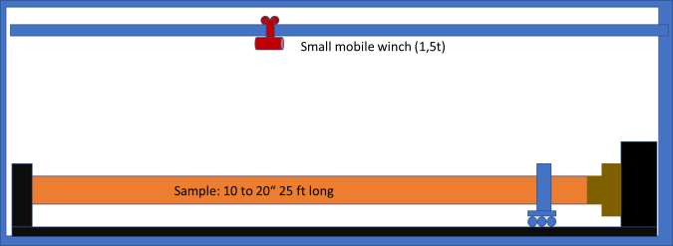  Figure 3. Section of the testing frame showing the outer pipe (orange) installed in the axial restrictive frame. The specimen is inside of the outer piepe, see figure 4. | 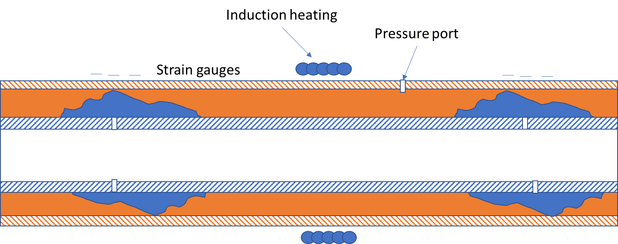  Figure 4. Heating is performed using induction coils (here only one showed)

Milestone 4.1 Full-scale testing setup ready for testing
Budget Period 1 Go/No-Go Decision Point: At the end of budget period 1, the first Prototype should prove that it has the potential to perform as listed in this FOA: temperature ration of minimum 225 deg C and differential pressure ratio of 6000 psi. If the study and experimental work are proved, the second optimized Prototype for field deployment will be built during the budget period 2.
SMART milestone: Proof of concept using the FEM and CFD for the Prototype built for testing and validation. Full reports and way forward proposals will be provided to DOE.

Budget Period 2: Prototype Manufacturing & Qualification
Task 5.0: Identify the best design of the metallic sealing elements to withstand the high differential pressure and elevated temperatures, M15-M24
This task will have three subtasks: 3.1. Design and construction of the testing setup, 3.2 testing of the specimen design in Task 2, and 3.3 investigate the long thermal degradation of the specimen.
Subtask 5.1: Calibration and verification of the testing procedure, M15 – M18
This subtask is necessary in order to adjust the testing protocol with the final version of the prototype to be built by Welltec.
Subtask 5.2: Testing of the specimen design in Task 2, M15 – M24
The delivered prototype will be tested according to the testing protocol defined in subtask 4.1.
Subtask 5.3: Investigate the long thermal degradation of the specimen, M15 – M24 (M36)
If the prototype will pass all steps of the testing protocols proposed in subtask 5.1 then long term tests will be initiated. These tests will continue during the period 3.

Budget Period 2 Go/No-Go Decision Point: At the end of the budget period 2, the second Prototype should prove that it has the potential to perform as listed in this FOA: temperature ratio of minimum 225 deg C and differential pressure ratio of 6000 psi.
SMART milestone: Proof of concept using the built for purpose optimized isolation tool, and that works under the desired downhole conditions. Computer design of a geothermal simulation job using the proposed isolation concept. The later will continue in the budget period 2 for another 3 months.

Budget Period 3 Field Deployment and Long-Term Investigations
Task 6.0: Build and test an optimized prototype in full length to demonstrate its maximum differential pressure and temperature capabilities for field application, M25-M30
This task is very similar to task 2. However, the experience gained through the work in Task 2.0, 3.0, 4.0 and 5.0 will flow into the development of an optimized prototype. As soon as the laboratory qualifications validate the tool performance, the field deployment tool consisting of multiple stages will be built and delivered to FORGE. We will work with FORGE R&D team to develop a plan for use of the packer system in different stimulation activities that will be carried out by FORGE and or other research teams.
Task 7.0: Long-Term Investigations and reporting.
Subtask 7.1: Long term investigations, M25 – M36
This subtask is necessary in order to to deeply understand the role of time and temperature variation on the proposed concept. Such investigations are usually not performed on conventional packer systems because they are expenesive and time intensive. This subtask will increase the understanding of long term and cyclic loading resisntance of the Welltec novel isolation system proposed herein.
Subtask 7.2: Reporting, M32 – M36
A detailed report will be prepared after field testing of the proposed system that will include lessons learned and specific informations generated during the whole project time frame..

MILESTONE SUMMARY
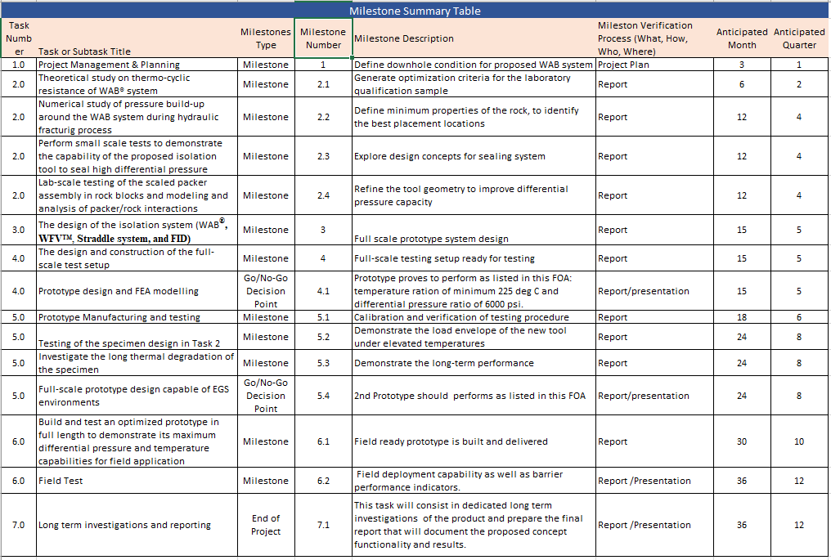

Risk Register
In order to mitigate some risks associated with the project we are from the beginning proposing two possible solutions that are sharing some of the research outcomes of the period 1. The major risk associated with the development of the isolations systems consists of the ability of the system to seal under elevated temperature and hold the isolation for a given period of time. As mentioned we are investigating the applicability of 2 different systems: one using performated liners in between to sections of WAB and one that uses the elastomeric free WFV. Since the meatlic packer concept has been already proven to work under high temperature conditions, we expect to have zero incidents with the WAB. However, more laboratory investigations will be performed in order to optimize and improve the WAB concept for multistage type of fracturing.

End of Project Goal: At the end of the project, one optimized field prototype that will be capable of withstanding 250 deg C and differential pressure of 6000 psi will be delivered. As a secondary result of the project, a testing setup will be made available for future testing of downhole tools.

Project Schedule: the project schedule is shown in the Gant chart below.
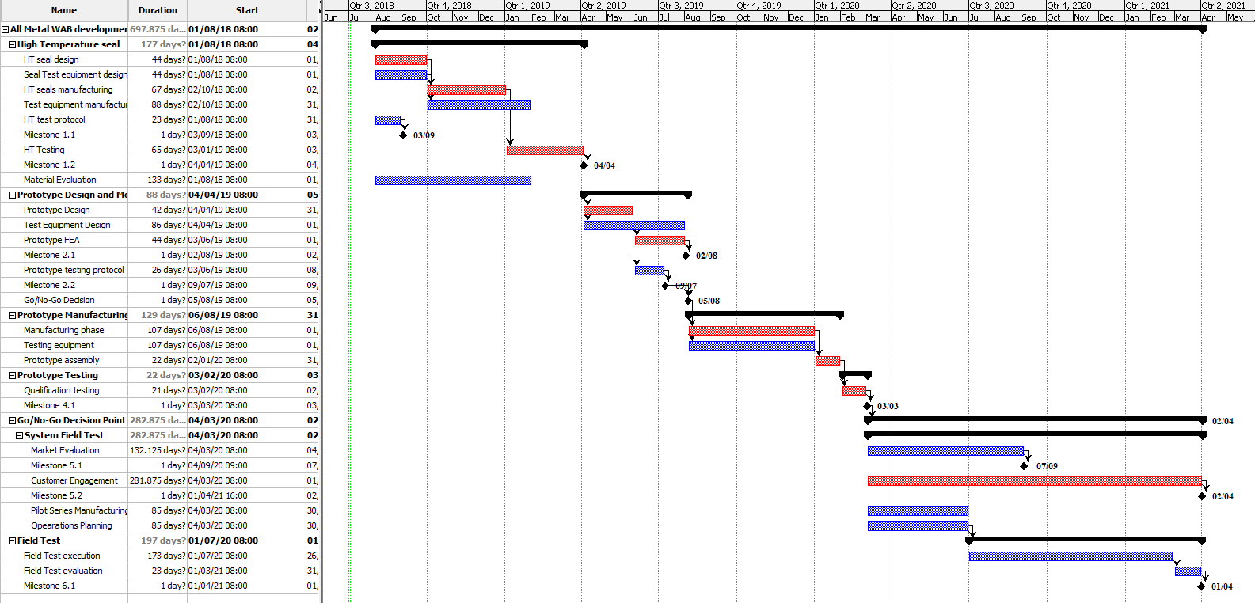

Project Management
Welltec® proposes a simple project structure for the execution of the technology extension required to modify the WAB® to enable its use in geothermal operations.
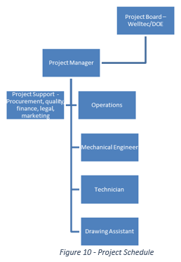
Project Team Composition

- Project Board - composed of Welltec® executives and Oklahoma University. The Project Board will represent the corporate management in overseeing the delivery of the project (project governance). They are responsible for the Go/No-Go decisions and approving testing protocols as agreed on the project plan.
- Project Manager – Welltec® employee that has successfully completed over 15 customer funded projects in the last 5 years. The overall responsibility of the Project Manager is to ensure that the project delivers the defined product within the agreed tolerances of benefit, time, risk, costs, quality and scope. The Project Manager is the director of the project organization, and must plan, manage and control the project’s progress daily on behalf of the Project Board.
- Operations Manager – Welltec® employee that has overseen all WAB® deployments since the product commercialization in 2011. The overall responsibility of the Operations Manager is to ensure the successful delivery of Performance/Budget Period 3 and all associated tasks.
- Mechanical Engineer – Welltec® employee with over 3 years’ experience in design and qualification of the WAB® product. The overall responsibility of the Mechanical Engineer will be to carry out the duties defined in Performance/Budget Period 1 & 2.
- Technician – Welltec® employee with over 3 years’ experience in system assembly and qualification of the WAB® product. The overall responsibility of the Technician will be to carry out duties as assigned by the Project Manager and Mechanical Engineer.
- Technical Drawing Assistant – Welltec® Employee with over 5 years of experience on the Catia 3D drawing program used in Welltec® engineering. The overall responsibility of the Technical Drawing assistant will be to carry out duties as assigned by the Project Manager and Mechanical Engineer.
- Rock Mechanics Expert (Dr. Ahmad Ghassemi) from OU will supervise the small scale and numerical work performed to understand the near wellbore behavior and interaction with the Welltec isolation tool.
- Drilling and Testing Expert (Dr. Catalin Teodoriu) from OU will supervise the numerical work of the mechanical components, will help with the optimisation process and will design, and build the full scale test setup and conduct the necessary experimenatel testing.

The Project Manager will ensure the project follows Welltec’s Product Development Project Model (CD-00038-0-WW-EN), with the aim of minimizing project risk and ensuring the project is delivered on time, to budget, and of the expected quality. The key actions are to create a Risk Register, Quality Plan, Product Description, Project Plan at the first stage of the project. A change management process is executed through an exemption request to be approved by the project board.

Data Management Plan
The project will have a dedicated SharePoint site within Welltec’s secure intranet, where all the project documentation will be stored. Design reviews, meeting minutes, project plans and testing reports will be generated in word document format and converted to pdf for sharing and storing in the project’s SharePoint site.
The material testing data will be generated in an Excel format, enabling it to be converted into useful data for the finite element modelling. Test data will be recorded as a raw format from sensors. Both raw data and converted Excel formats will be stored in the project folder.
The 3-D design work on the high temperature seal, test equipment, prototype, and pilot series will be stored in Catia V5 Cad format. The design will also be stored in step files for modelling purposes and pdf for manufacturing.
Quarterly project reports will be generated in a PowerPoint format for sharing with the project board.
All tests will be fully documented with the raw data recorded at 1 Hz and stored in the project SharePoint folder. The test report will be documented in a PDF and distributed to the project board.
Data deemed to be confidential will be clearly market and IP protection will be applied when appropriate.
The results of the project and the publication of its results may encourage applications in other important energy fields. Total data size is not likely to exceed 20 gigabytes. Considering that basic consumer hard drives of up to 10 terabytes cost about $300, data storage size will not be an issue.

Technical Qualifications and Resources
Organizational Capabilities and Experience:
Welltec® will partner with The University of Oklahoma in this research. All the organizations involved in this project have successfully handled research projects with similar levels of complexity as the proposed project.The University of Oklahoma has long been recognized as having the leading Petroleum Engineering Department in the U.S. It has an established drilling and completion research center (Well Construction Technology Center) to perform studies that have applications in drilling and completion operations. The Well Construction Technology Center (WCTC) incorporates both field-scale and lab-scale test facilities to carry out experiments for the oil and gas industry. The rock mechanic laboratory at OU is one of the largest in the nation consisting of multiaxial loading cells and large polyaxial cell capable to accommodate large rock samples and operate at elevated temperatures. Some of the small scale tests related with the rock mechanic will be perfomed in this laboratory.
Welltec® has a dedicated engineering teams in Esbjerg- Denmark, Macae-Brazil, and Houston-USA working on continual improvement of the WAB® design. The proposed project will be conducted in Oklahoma-USA, using American workers. Since its inception, Welltec® has qualified over 15 different products for operators in North and South America, Europe, Africa, Middle East, Russia, Far East, Japan and Australia. The team has a deep understanding on the design parameters and operational capability of the system.
The engineering team will be fully dedicated to the project during the design and testing phases, with 10% utilization during the manufacturing phase (Non-conformance acceptance as required).
A summary of a recent WAB® project can be used as a reference with regards the capability of the current technology platform. Table 3 displays a successful qualification test sequence performed for an operator in the North Sea, it demonstrates the ability for the system to withstand extreme temperature and pressure cycles (10,000 psi).

Table 3 Qualification test example
Type | Test number | T, DegC C | Pa | Pb | Pc
WAB® expansion | 1 | 160 | 0 | 0 | 6,500
Injection B side | 2 | 160 | 500 | 10,500 | 10,500
Injection A side | 3 | 160 | 10,500 | 500 | 10,500
Injection B side | 4 | 50 | 500 | 10,500 | 500
Injection A side | 5 | 50 | 10,500 | 500 | 10,500
Injection B side | 6 | 160 | 500 | 10,500 | 10,500
Injection A side | 7 | 160 | 10,500 | 500 | 500

This demonstrates Welltec’s experience in customizing the WAB® to meet specific pressure / temperature ratings and expertise in material selection, design analysis, and simulated condition testing.

Qualifications of Key Personnel:
All the technical members who will work on this project have extensive experience in the area of drilling, and high-temperature experiments and modeling. The Principal Investigator (PI),
The co-PI Dr. Catalin Teodoriu is an Associate Professor in the Mewbourne School of Petroleum and Geological Engineering at the University of Oklahoma. He has more than 20 years of experience in the petroleum industry and academia, with key qualifications and research in drilling and production equipment, drilling technology, integrated computer-aided analysis, well completion, testing of OCTG, design of downhole and surface equipment, software development, EOR, and geothermal wells, and in the design of laboratory-specific equipment (i.e., high-pressure testing, large scale testing equipment for multiphase flow and drilling prochigh ess simulation). One of the major geothermal projects that he managed was Geothermal and High-Performance Drilling (Gebo), where he acted as a focal point for drilling and well-completion with nine sub-projects. Also, he was a member of the Advisory Board. He is the author of more than 160 publications, from which more than 40 are peer-reviewed. The Co-PI, Ahmad Ghassemi, is a Rock Mechanics Professor and the McCasland Chair at OU. He specializes in the geomechanics of unconventional geothermal and petroleum reservoir development, and has been working on reservoir rock mechanics/modeling for the past twenty years with emphasis on thermo-poroelastic effects in reservoir stimulation. At O.U. Dr. Teodoriu will be responsible for the design of the field0scalefield scale prototypes and its experimental testing. Dr. Ghassemi will be responsible for numerical work as well as rock block testing experiments for lab-scaled prototype testing that will be carried out at O.U. Ricardo Vasques is the Engineering manager in Welltec and has over 30 years of oilfield experience including 20 years working for Schlumberegr R&D prior to his curtrent assignment with Welltec.

Organizational Capabilities and Experience: University of Oklahoma

The University of Oklahoma's tradition of excellence in energy education dates back to 1919. The University has long been recognized as having the leading Petroleum and Geological Engineering Department (The Mewbourne School of Petroleum and Geological Engineering) in the U.S. As a leading petroleum research institution. The department provides the industry with the development and implementation of innovative technology that will improve the efficiency and economic viability of drilling, completion, and production operations. Several research projects that are supported by service companies, major oil companies, and government agencies have been successfully completed in the department. In recent years, The Mewbourne School of Petroleum and Geological Engineering (MPGE) has gained a well-deserved recognition through its research in various areas. The industry has widely implemented the technical knowledge and know-how developed at the MPGE's research centers. Some of the major research centers are i) Integrated Core Characterization Center, ii) PoroMechanics Institute, and iii) Well Construction Technology Center.

The University of Oklahoma has an established technology research center (Well Construction Technology Center) to perform researches that have applications in drilling and completions operations. The Well Construction Technology Center (WCTC) incorporates both field-scale and lab-scale test facilities to carry out experiments for the oil and gas industry. Several research projects with similar levels of complexity as the proposed project have been successfully completed at the center. This facility will be used to conduct the proposed research. The University of Oklahoma has a lab furnished with standard equipment to prepare and test well cement according to existing standards. E-modulus, compressive strength, slurry properties can be measured and documented. Major lab equipment already available for this project are: i) cement aging setup that has two high-pressure high-temperature (HPHT) cement autoclaves; ii) compressive and bonding strength ASME certified measuring apparatus; iii) porosity and permeability measuring device; iv) SEM imaging; v) cement consist-o-meter; vi) rotational viscometer; vii) filter press, and viii) cement blender.
Well Construction Technology Center: The Well Construction Technology Center (WCTC) of the University of Oklahoma has the required resources and capabilities to conduct the proposed research. WCTC (Fig. 2) is equipped with the necessary facilities to conduct the proposed research. It has a large indoor laboratory space (60 ft × 40 ft × 30 ft) to build and operate the high-pressure fracture simulator (HPFS). Also, the center has a very large outdoor area with a concrete slab to place heavy pieces of machinery and equipment. The total area of the center is approximately 10,000 square feet. The indoor lab is furnished with an overhead traveling crane to assemble test sections and heavy equipment.
Major research facilities available at the center include i) mixing and storage equipment; ii) fluid circulation system; iii) low-pressure fracture simulator (LPFS); iv) high-pressure simulator (HPS); v) foam flow loop; vi) heat exchanger, and vii) coiled tubing facility. The following facilities and equipment are needed to perform the proposed research:
Mixing and Storage Equipment: The mixing system has two 50-bbl tanks with paddles. The system has a small centrifugal pump to aid the mixing of gels and sand slurries and transfer fluid. Also, it has a bulk storage tank that holds approximately 600 sacks of frac sand. The system will be used to test the WFV.

